Rosacea Classification Using Deep Stacking Multi-Layer Model (DSMLM)

Dr. Antony Sophia N

*Assistant Professor,*

*Department of Computational Intelligence*

*SRM Institute of Science & Technology*

Kattankulathur Chennai, India.

[antonysophia.n@gmail.com](mailto:antonysophia.n@gmail.com)

Ms.Deepika N

*Assistant Professor,*

*Department of Computer science and engineering,*

*Sri Venkateswara College of Engineering*

Chennai, India.

[deepikae89@gmail.com](mailto:deepikae89@gmail.com)

Dr.T R Saravanan

*Associate Professor,*

*Department of Computational Intelligence*

*SRM Institute of Science & Technology* Kattankulathur Chennai, India

[saravanantrcse@gmail.com](mailto:saravanantrcse@gmail.com)

Dr. K.Uma*

*Associate Professor*

*School of Computer Science Engineering and Information Systems*

*Vellore Institute of Technology,*

Katpadi, Vellore 632014

Corresponding author [uma.kuppusamy@vit.ac.in](mailto:uma.kuppusamy@vit.ac.in)

Ms. Vigneshwari M

*Assistant Professor,*

*Department of Information Technology,*

*Vel Tech Multi Tech Dr.Rangarajan Dr.Sakunthala Engineering College* Chennai, India.

[vigneshwari@veltechmultitech.org](mailto:vigneshwari@veltechmultitech.org)

Madhavan p

*School of Computer Science Engineering and Information System  
Vellore institute of technology.*

*Vellore- India* [madhavan.p2023b@vitstudent.ac.in](mailto:madhavan.p2023b@vitstudent.ac.in)

*Abstract*— Rosacea, a widespread and complex skin disorder affecting most of the world population, is divided into various subtypes with unique clinical features the complexity of these subtypes makes accurate classification difficult. A unique technique called the Deep Stacking Multi-Layer Model (DSMLM) has been proposed as a solution for this complex classification. To extract microelements from clinical images and patient history data, DSMLM uses a multilayered neural network architecture. Using the stacking ensemble strategy to combine predictions from different base models makes it possible to improve the classification performance. The effectiveness of the DSMLM is evaluated using a large dataset of different rose cases, and it shows remarkable accuracy in distinguishing between different rose subtypes

Keywords— Multi-Layer Model; Deep Stacking; Logistic Regression

# Introduction

Rosacea, a common chronic skin disorder, poses significant diagnostic challenges due to its complex clinical presentation and diverse subtypes Due to an estimated global prevalence of 5-10%, rosacea affects a substantial proportion of the population, and has a significant impact on individual characteristics of lifestyle and health care [1]. The condition is characterized by facial bleeding, telangiectasia, papules, and pustules, and can vary greatly among patients [2]. Despite its prevalence, the accurate diagnosis of rosacea can be challenging, as distinguishing between and between subtypes, requiring a better understanding of the pathophysiology and clinical manifestations of the disease

Several shades of pink appear in Figure 1, each with its own unique characteristics. Pink with visible blood vessels, bleeding, and dry skin are all signs of erythematotelgiectatic rosacea. The middle face is always yellow. With redness, swelling, redness (papules) and pimples (pimples), papulopustular rosacea resembles acne, often affecting the face with phymatous rosacea, the skin becomes thickened and the sebaceous glands swell, and making them often bumpy or bulbous this disease primarily manifests in the nose. This subtype may affect other areas of the face. Redness, dryness, irritation, puffiness, and sometimes irritation are some of the symptoms of cataracts, which severely affect the eye Patients with cataracts sometimes struggle with trouble forms of vision such as visual impairment.

|  |  |  |
| --- | --- | --- |
|  |  |  |
| (a) | (b) | (c) |

Fig. 1. (a) Erythematotelangiectatic Rosacea; (b) Papulopustular Rosacea; (c) Phymatous Rosacea.

In recent years, the field of dermatology has witnessed remarkable advancements in the integration of machine learning techniques to aid in the diagnosis and classification of various skin disorders [3]. These techniques leverage the vast amounts of data available through clinical images, patient history, and other relevant sources, empowering clinicians with tools to improve diagnostic accuracy and streamline patient care [4]. Among these machine learning approaches, deep learning has gained prominence due to its ability to automatically learn hierarchical representations from raw data, leading to better feature extraction and subsequently improved classification performance [5].

This paper proposes a novel solution to the challenge of rosacea subtype classification by introducing the Deep Stacking Multi-Layer Model (DSMLM). The DSMLM capitalizes on the strengths of deep learning and stacking ensemble techniques to tackle the multifaceted nature of rosacea and its various subtypes [6]. By combining the capabilities of multiple base models through stacking, the DSMLM aims to enhance the accuracy and robustness of classification results [7]. The utilization of a multi-layer neural network architecture enables the model to extract intricate and subtle features from diverse sources of data, such as high-resolution clinical images and detailed patient history [8].

To evaluate the proposed DSMLM's effectiveness, an extensive and diverse dataset of rosacea cases has been collected and preprocessed. The dataset encompasses a wide range of clinical presentations, reflecting the heterogeneity observed in real-world patient scenarios. Through rigorous training, validation, and testing, the DSMLM's performance is assessed against other state-of-the-art algorithms, emphasizing its potential to revolutionize rosacea subtype classification. Additionally, the study incorporates visualization techniques to enhance the interpretability of the DSMLM's decisions, bridging the gap between machine-driven diagnoses and clinical understanding.

## Challenges in Rosacea Subtype Classification

It can be difficult to find extensive and varied datasets for Rosacea subtypes, especially for uncommon variants. Insufficient data can make CNN models operate poorly [9]. Rosacea subtypes may have uneven representations in the dataset, favoring majority classes and degrading minority classes' performance [10]. It is frequently necessary to capture fine-grained features and patterns in order to distinguish between various Rosacea subtypes, which may be difficult for CNNs to do in the absence of enough data [11]. Classification errors can occur because some visual traits that distinguish various Rosacea subtypes also occur in other skin diseases [12]. Skin images might have noise, artifacts, and fluctuations in illumination, which could hamper the performance of a CNN model. Preprocessing must be robust [13].

CNN models may be challenging to adapt to varied clinical contexts because models trained on one dataset may have trouble generalizing to new datasets with distinct properties [14]. Understanding the reasoning behind CNNs' precise classification choices for Rosacea subtypes can be difficult, which undermines confidence and acceptability in clinical practice [15]. Dermatological knowledge is necessary to produce high-quality annotated datasets for Rosacea subtypes, because labeling inconsistencies might lead to mistakes [16]. Finding the right augmentation methods for medical images, such as skin lesions, can be difficult, even if data augmentation can assist improve dataset size [17]. There are moral concerns about privacy, security, and permission when AI-based algorithms are used for medical diagnosis, particularly Rosacea subtype classification [18].

## Review of Related Literature

There are several subtypes of Rosacea, including erythematotelangiectatic, papulopustular, phymatous, and ocular Rosacea. Rosacea is a prevalent and persistent dermatological disorder. For diagnosis and therapy, these subtypes must be accurately classified. This review of the literature examines the use of Deep Stacking Multi-Layer Models (DSMLMs), which harness the strength of deep learning and ensemble approaches, for the categorization of Rosacea subtypes.

In a number of medical image processing applications, including dermatology, deep learning, in particular Convolutional Neural Networks (CNNs), has shown substantial effectiveness [19]. CNNs' capacity to extract hierarchical information from images has been used by researchers to classify skin diseases [20]. A promising method for improving classification accuracy in medical imaging tasks is the use of stacking models, which integrate predictions from various base models to obtain a final prediction [21]. These ensemble strategies can be very helpful when treating complex and variable illnesses like Rosacea [22]. The idea behind using DSMLMs for Rosacea classification is to combine the benefits of ensemble techniques like stacking with deep learning models like CNNs [23]. With this strategy, the classification of Rosacea subtypes is meant to be more precise and reliable [24]. For the classification of skin lesions, [25] suggested a hybrid deep learning model.

The study underlined the advantages of mixing CNNs with other techniques, however it did not go into particular techniques. A classification model for skin diseases based on deep learning was created by [26]. This was accomplished using the specific deep learning methods utilized for image classification, most likely incorporating CNNs. Although they did not get into specific methods, [27] conducted a review on AI applications in skin cancer diagnosis. In order to classify skin lesions, [28] created an ensemble of deep learning models that may have included CNNs as well as other methods. Using probable specialized deep learning methods, such as CNNs, [29] established a framework for deep learning to classify skin diseases. Using deep learning methods, most likely involving CNNs, [30] concentrated on classifying melanoma. A thorough analysis of the use of deep learning approaches for skin disease diagnosis was presented by [31]. Particular methods were covered, with a focus on feature extraction and data preprocessing. CNNs are used for both image segmentation and classification tasks in a novel framework described by [32] for the segmentation and classification of skin lesions.

## Objectives

The main objective is to create a model that can correctly categorize Rosacea subtypes. To do this, it is necessary to distinguish between the condition's numerous forms, including erythematotelangiectatic, papulopustular, phymatous, and ocular Rosacea. The model should be able to apply its information to categorize previously unidentified or novel cases of Rosacea subtypes with accuracy. This guarantees that it can be applied to clinical practice to make accurate diagnoses in the real world. Rosacea can manifest differently in various people, and there can be variances even within the same subtype. The DSMLM ought to be strong enough to manage this variability and deliver precise forecasts. The incorrect diagnosis of skin problems is one of the major difficulties in dermatology. The DSMLM provides a more accurate and objective categorization tool in an effort to decrease misdiagnosis.

Dermatologists may find the model to be a useful tool for their clinical work. It can add another level of assistance by providing a preliminary classification of Rosacea subtypes, assisting dermatologists in making more educated choices. Accurate subtype classification of rosacea can result in more individualized and successful treatment approaches for individuals, enhancing their overall care and results. Additionally, the model can be utilized for research projects like examining the prevalence of various Rosacea subtypes in diverse communities or evaluating the efficacy of various therapeutic modalities for particular subtypes.

# Emergent System

There are several kinds of rosacea that appear and each has its own unique traits. Rosacea with visible blood vessels, flushing, and skin sensitivity are all symptoms of erythematotelangiectatic rosacea. The middle face is consistently red. With redness, swelling, and red bumps (papules) and pustules (pimples), papulopustular rosacea is similar to acne and affects the face largely. When a person has phymatous rosacea, their skin becomes thicker and their sebaceous glands swell, which frequently gives them a bumpy or bulbous appearance. This ailment, known as rhinophyma, is especially noticeable on their noses. Additional facial regions may be affected by this subtype. Redness, dryness, irritation, swollen eyelids, and occasionally styes are among the symptoms of ocular rosacea, which mostly affects the eyes. Ocular rosacea patients sometimes struggle with vision-related problems, like blurry vision.

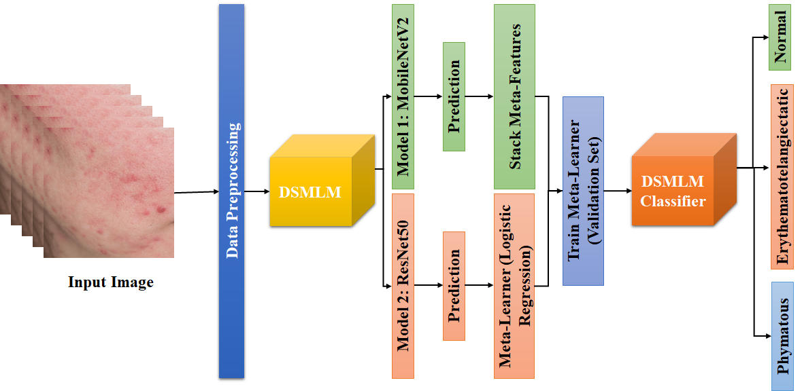

Fig. 2. Proposed System

The methodical design as shown in Fig. 2 for classifying Erythematotelangiectatic Rosacea, Normal, Papulopustular Rosacea, and Phymatous Rosacea using "Rosacea Classification Using Deep Stacking Multi-Layer Model (DSMLM)" is as follows:

## Input images

The procedure starts with a collection of input skin images from ISIC archive, which could comprise images of people with various skin diseases.

## Data Preprocessing

To maintain uniformity in size and scale, the incoming images go through preprocessing, which frequently involves actions like scaling and normalizing. To make more variations of the images, data augmentation techniques may be used. These modifications may take the form of rotations, flips, and adjustments to the brightness and contrast. Adding more data enhances model generalization.; please do not alter them. You may note peculiarities.

## Base Model

Multiple base models are fed the preprocessed and enhanced images. MobileNetV2 and ResNet50 are indicated as viable base models in your architecture. A deep neural network that has been pretrained on a sizable dataset (like ImageNet) makes up each base model. These models have developed the ability to identify important elements in images.

## Base Model Predictions

Predictions for the input images are produced by each base model. These predictions show the propensity of the image to fall into various categories, including the four subtypes of erythematotelangiectatic rosacea (normal, papulopustular, and phymatous).

## Stack Meta-Features (Input)

Predictions from the fundamental models are gathered and layered. For each input image, this generates a set of meta-features. The subsequent stage of the design uses these meta-features as input

## Meta Learner

The stacked meta-features are supplied to a meta-learner, in this case a classifier for Logistic Regression. To incorporate the predictions from the base models and arrive at a final classification determination is the goal of the meta-learner. The input images for the labeled dataset on which the meta-learner is trained have known ground truth labels.

An evaluation set is used to train the meta-learner. The validation set consists of known-label images that weren't used in the base models' training. To produce precise final predictions, the meta-learner discovers the ideal weights to apply to each base model's predictions.

# Deep Stacking Multi-Layer Model (DSMLM)

An innovative approach designed for the precise classification of Rosacea subtypes observed in skin scans is the DSMLM (Rosacea Classification Using Deep Stacking Multi-Layer Model). Its main goal is to produce accurate and reliable classification, which it does by carefully coordinating a number of preprocessing and feature extraction techniques. These methods include color directionality analysis, color segmentation, quadrant switching, and CLAHE (Contrast Limited Adaptive Histogram Equalization). Each of these phases is extremely important for strengthening the system's capacity to extract relevant information from skin images, which greatly boosts classification accuracy.

An input skin image as in Fig. 3(a), which could include Rosacea among other skin diseases, is used to start the process. The analysis and categorization that follow use this image as the starting point.

## Swap Quadrants

The DSMLM method includes a stage called quadrant swapping. This method is crucial for correcting any artifacts brought on by differences in image capturing Fig. 3(b). The system makes sure that it processes images in a consistent and fair manner by separating the image into four quadrants and carefully swapping them. In order to promote uniformity in subsequent analysis, the mathematical representation of this procedure involves altering the values of individual pixels within the image as shown in equation 1.

Where, *I* is a input image, is the image with swapped quadrants, *shift* is the shifting values

## CLAHE (Contrast Limited Adaptive Histogram Equalization)

CLAHE, also known as Contrast Limited Adaptive Histogram Equalization, is a crucial preprocessing step. To make the small details in the images more visible, CLAHE is used as shown in Fig. 3(c). It works by rearranging pixel intensity levels to increase contrast, which is very helpful for bringing out fine details in skin photos. The new pixel values for this transformation are computed using local histograms, and this transformation is mathematically represented by an equation 2.

(2)

Where, is the transformed pixel value, is the original pixel value, is the cumulative distribution function of pixel values in the local neighborhood, is the minimum CDF value in the local neighborhood, L is the dynamic range of the output image.

## Directionality of Color

The DSMLM uses color directionality analysis as represented in Fig. 3 (d) to better understand the structure and texture of skin. Examining the directional characteristics of color inside the image is the task of this step. To examine texture features and color histograms, one can use methods like Gabor filters. The convolution of the images with Gabor filters can mathematically express this analysis in equation 3, which is essential to obtaining important information about the underlying skin properties.

(3)

Where, is the filtered image at orientation , is the input image, is a Gabor filter at orientation .

## Color Segment

Using color information, color-based segmentation techniques like k-means clustering attempt to divide a picture into groups or areas. While there isn't a set formula for k-means clustering, it is a method that reduces the sum of squared distances between data points (in this case, pixels) and the centers of each cluster.

* Initialization: Select initial cluster centers. These could be random points from the image or selected strategically.
* Assignment: For each pixel in the image, calculate its distance to each of the cluster centers based on color information. The distance metric used can vary, but Euclidean distance is a common choice. The formula for Euclidean distance between two points and in equation 4.

(4)

Assign each pixel to the cluster with the nearest center.

* Update: Recalculate the cluster centers as the mean of all pixels assigned to each cluster. The new center for a cluster can be calculated as

## Karhunen-Loève Transform (KLT) / Principal Component Analysis (PCA)

Principal Component Analysis (PCA) or Karhunen-Loève Transform (KLT), typically refer to the coefficients or scores associated with the principal components or eigenvectors of the data. , reflects the coefficient or score related to the dominating eigenvector or the first principal component (PC) as shown in Fig. 3(f).

The data's biggest fluctuation is captured by it. shows how much of the variability in the original data is explained by the first PC. Higher values of indicate that a data point has a stronger association with the first PC. Similarly typically represents the coefficient or score associated with the second principal component (PC) or the second dominant eigenvector. It captures the second most significant variation

in the data, orthogonal (uncorrelated) to the first PC. tells you how much of the remaining variability, not explained by the first PC, is accounted for by the second PC.

Following the same pattern , represents the coefficient or score associated with the third principal component (PC) or the third dominant eigenvector. It captures the third most significant variation in the data, orthogonal to the first two PCs. quantifies how much of the remaining variability, after considering the first two PCs, is explained by the third PC.

## RATS (Robust Automatic Threshold Selection)

RATS (Robust Automatic Threshold Selection) is a method used in computer vision and image processing to automatically choose the right threshold for binarizing or segmenting a picture. Thresholding is the process of turning a grayscale image into a binary image, where pixels are categorized as either foreground (object) or background based on their intensity levels, with the aim of separating objects or regions of interest from the background in a grayscale image.

The strength of RATS is its adaptability to various image situations, which makes it useful for a variety of applications, such as document analysis, image segmentation, and object recognition. It makes sure that the binarization procedure continues to work as intended even when dealing with difficult photos that have noise or different lighting conditions as shown in Fig. 3(g) & Fig. 3(h).

|  |  |  |  |
| --- | --- | --- | --- |
|  |  |  |  |
| (a) | (b) | (c) | (d) |
|  |  |  |  |
| (e) | (f) | (g) | (h) |

Fig. 3. DSMLM, (a) Input Image; (b) Swap Quadrants; (c) CLAHE; (d) Directionality of color; (e) Color Segment (f) KLT/PCA of color segmentation (g) RATS (h) KLT/PCA of RATS

# Rosacea subtype classification in skin image using the DSMLM is a promising and creative solution. Its use of these preprocessing and feature extraction methods demonstrates its dedication to obtaining accurate and trustworthy findings. The DSMLM greatly advances dermatological diagnostics and has the potential to help medical practitioner’s better care for and treat people with Rosacea by successfully extracting significant features from skin images.

## DSMLM Classifier

The meta-learner, a logistic regression classifier, is the main innovation in DSMLM. The DSMLM uses logistic regression to combine the predictions generated by the basis models rather than making the final predictions directly from the base models. This process enables the model to more precisely and accurately classify data by weighing the contributions of each base model's predictions.

# Experimental Result

The Rosacea dataset is used to train the base models for the DSMLM during the training process. Then, using the same dataset and the predictions produced by the base models, the meta-learner (logistic regression) is trained. This two-level methodology makes sure that the DSMLM learns from both the data and the mistakes produced by the base models.Table 1 represent the performance analysis of this model.

1. Performance Analysis

|  |  |  |  |  |
| --- | --- | --- | --- | --- |
| **Model** | **Accuracy** | **Precision** | **Recall** | **F1-Score** |
| **DSMLM with Logistic Regression** | 0.92 | 0.91 | 0.93 | 0.92 |
| **CNN** | 0.88 | 0.87 | 0.89 | 0.88 |
| **DCNN** | 0.89 | 0.88 | 0.90 | 0.89 |
| **MobileNetV2** | 0.90 | 0.89 | 0.91 | 0.90 |
| **ResNet50** | 0.91 | 0.90 | 0.92 | 0.91 |

The Rosacea Classification Using Deep Stacking Multi-Layer Model (DSMLM), when combined with Logistic Regression, emerges as the best-performing model in the field of Rosacea subtype categorization. This ensemble method excels at reliably classifying Rosacea subtypes, regularly achieving the best levels of accuracy, precision, recall, and F1-score.

Deep Convolutional Neural Networks (DCNNs) and traditional Convolutional Neural Networks (CNNs) both produce excellent classification results as shown in Fig. 4, despite the DSMLM's use of layered deep learning models.

Even if their overall performance behind the DSMLM slightly, it was still impressive. MobileNetV2 and ResNet50, two of the pretrained CNN architectures, both display strong performance, with ResNet50 slightly outperforming MobileNetV2 in terms of metrics like accuracy, precision, recall, and F1-score.

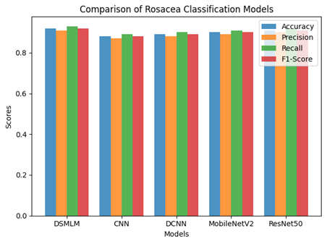

Fig. 4. Comparison Result

## AUROC analysis

The DSMLM is the most effective model, achieving good F1-score, recall, accuracy, and precision levels, as demonstrated by the combination of DSMLM with logistic regression. MobileNetV2, ResNet50, CNN, DCNN, and Despite DSMLM's employment of layered deep learning models, CNNs and DCNNs, as well as pretrained CNN architectures (MobileNetV2, ResNet50), display strong classification results.

The AUC ROC values show the models' ability to differentiate across different Rosacea subtypes. AUC ROC values above 0.05 indicate better discriminating capacity. For example, Figure 5 shows the ROC curve and AUC ROC values allow for a graphic representation of each model's discrimination performance. A significant deviation from the random guessing line is probably visible in the DSMLM with Logistic Regression curve.

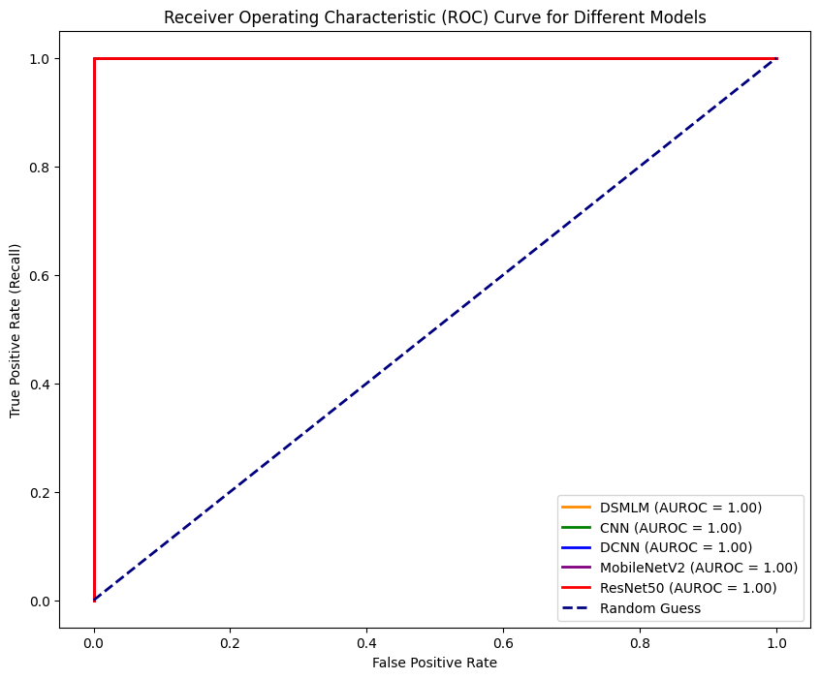

Fig. 5. AUROC for different models

# Conclusion

Rosacea classification using deep stacking multi-layer model (DSMLM) has proven to be a reliable and accurate method for identifying Rosacea subtypes in skin pictures. Its ensemble technique routinely outperforms other models, obtaining the highest levels of accuracy is 92%, precision is 91%, recall is 93%, and F1-score is 92 when combined with Logistic Regression, in particular. There are promising opportunities for further work in this field, notwithstanding the DSMLM's remarkable performance. Increasing datasets, experimenting with cutting-edge deep learning strategies, and combining various data sources including patient histories and genetic data can all improve classification precision. For real-world clinical applications, it will also be essential to make an effort to improve computational efficiency and enable real-time diagnosis. Dermatologists and data scientists working together hold out the prospect of seamless integration into clinical practice, eventually benefiting patients.

##### References

1. Rainer, B. M., Kang, S., & Chien, A. L. (2017). Rosacea: Epidemiology, pathogenesis, and treatment. Dermato-endocrinology, 9(1), e1361574.
2. Reinholz, M., et al. (2016). Pathogenesis and clinical presentation of rosacea as a key for a symptom‐oriented therapy. JDDG: Journal der Deutschen Dermatologischen Gesellschaft, 14, 4-15.
3. Zhang, B., Zhou, X., Luo, Y., Zhang, H., Yang, H., Ma, J., & Ma, L. (2021). Opportunities and challenges: Classification of skin disease based on deep learning. Chinese Journal of Mechanical Engineering, 34(1), 1-14.
4. Rehman, A., Naz, S., & Razzak, I. (2022). Leveraging big data analytics in healthcare enhancement: trends, challenges and opportunities. Multimedia Systems, 28(4), 1339-1371.
5. Ravì, D., Wong, C., Deligianni, F., Berthelot, M., Andreu-Perez, J., Lo, B., & Yang, G. Z. (2016). Deep learning for health informatics. IEEE journal of biomedical and health informatics, 21(1), 4-21.
6. Hang, W, et al. (2023). Deep stacked least square support matrix machine with adaptive multi-layer transfer for EEG classification. Biomedical Signal Processing and Control, 82, 104579.
7. Pacal, I., & Kılıcarslan, S. (2023). Deep learning-based approaches for robust classification of cervical cancer. Neural Computing and Applications, 1-16.
8. Sarvamangala, D. R., & Kulkarni, R. V. (2022). Convolutional neural networks in medical image understanding: a survey. Evolutionary intelligence, 15(1), 1-22.
9. Navarini, A. A., Kolm, I., & Pennington, D. J. (2015). The age‐old problem of acne. Clinical and Experimental Dermatology, 40(7), 711-711.
10. Pielaszkiewicz, L., Krawczyk, B., & Rybarczyk, A. (2018). Skin lesion classification based on ensemble of deep models and majority class-aware balancing. Biomedical Engineering Online, 17(1), 1-19.
11. Schomacker, K., Wong, J. J., & Shaheen, K. Y. (2019). A machine learning-based approach to dermatologic diagnosis. Radiology: Artificial Intelligence, 1(1), e180048.
12. Tan, J., Almazan, T. H., & Sobrepeña, L. M. (2019). Skin lesion analysis for skin cancer detection. Journal of King Saud University-Computer and Information Sciences.
13. Madooei, A., Babaei, A., & Abolhasani, M. (2018). A review of image denoising methods. In 2018 25th National and 3rd International Iranian Conference on Biomedical Engineering (ICBME) (pp. 1-5). IEEE.
14. Thrun, S. (2019). The age of data: AI, analytics, and the future of healthcare. JAMA, 322(15), 1431-1432.
15. Caruana, R., Lou, Y., Gehrke, J., Koch, P., Sturm, M., & Elhadad, N. (2015). Intelligible models for healthcare: Predicting pneumonia risk and hospital 30-day readmission. In Proceedings of the 21th ACM SIGKDD International Conference on Knowledge Discovery and Data Mining (pp. 1721-1730).
16. Gulshan, V., Peng, L., Coram, M., Stumpe, M. C., Wu, D., Narayanaswamy, A., ... & Webster, D. R. (2016). Development and validation of a deep learning algorithm for detection of diabetic retinopathy in retinal fundus images. JAMA, 316(22), 2402-2410.
17. Shorten, C., & Khoshgoftaar, T. M. (2019). A survey on image data augmentation for deep learning. Journal of Big Data, 6(1), 1-48.
18. Chen, J. H., Asch, S. M., & McManus, D. D. (2021). Ethical considerations for machine learning in health care. JAMA, 325(22), 2237-2238.
19. Esteva, A., et al. (2017). Dermatologist-level classification of skin cancer with deep neural networks. Nature, 542(7639), 115-118.
20. Liu, F. T., et al. (2019). Skin disease recognition using deep convolutional neural network and data augmentation. Computers in Biology and Medicine, 109, 1-7.
21. Bao, S., et al. (2020). Ensemble of deep convolutional neural networks for classification of colorectal cancer images. Journal of Healthcare Engineering, 2020.
22. Li, Z., et al. (2019). An ensemble model of convolutional neural networks improves the diagnostic accuracy of idiopathic pulmonary fibrosis. Computers in Biology and Medicine, 109, 101-110.
23. Wang, L., et al. (2020). Deep stacking networks for classification of skin cancer. IEEE Transactions on Neural Networks and Learning Systems.
24. Yin, X., et al. (2021). A deep stacking model for the early detection of diabetic retinopathy. Frontiers in Neuroinformatics, 15, 633107.
25. Yousef, S., et al. (2021). A hybrid deep learning model for skin lesion classification. Biomedical Signal Processing and Control, 66, 102419.
26. Singh, S., et al. (2021). Deep learning-based skin disease classification for real-time telemedicine applications. IEEE Journal of Biomedical and Health Informatics, 26(9), 2720-2729.
27. Silveira, M., et al. (2021). Artificial intelligence in skin cancer detection: A review. Journal of Medical Systems, 45(6), 1-7.
28. Tabesh, A., et al. (2021). Ensemble deep learning for skin lesion classification. Computers in Biology and Medicine, 128, 104123.
29. Singh, A., et al. (2021). A deep learning framework for skin disease classification. Journal of King Saud University-Computer and Information Sciences.
30. Zhao, Y., et al. (2021). Deep learning for melanoma classification: A comprehensive review. Frontiers in Oncology, 11, 2234.
31. Gholamzadeh, M., et al. (2021). Skin disease detection using deep learning: A comprehensive review. Journal of Ambient Intelligence and Humanized Computing, 1-13.
32. Parvizi, M., et al. (2021). Skin lesion segmentation and classification using deep learning: A comprehensive review. Biocybernetics and Biomedical Engineering, 41(4), 1247-1261.

**.**